AIML399 Pick-a-path-Ethics Project Readme file

Preparation

Installation
The following libraries must be installed in order to run the application:

Usage
When you run it, the programme should ask you to enter the name of the data file you want to load. If it is incorrect you have 5 attempts.
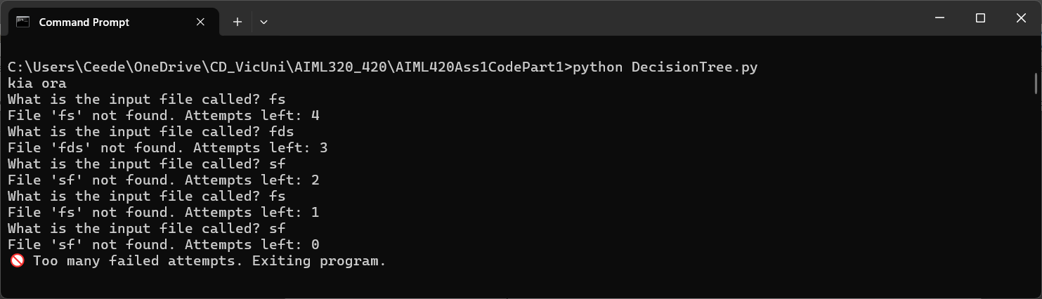

Running the app

There are no known bugs in the executables.

Acknowledgements

Initial structure provided by chat-GPT & broken into files, user input and debugging added then commented by Ceedee.
The programme is available for anyone to use – CC BY-NC-SA licence.

Contacts
ceedee@crystaldelta.co.nz

